NODEJS PART-2 ASSIGNMENT-1

Create an API to collect data from URL using Node and Express

Create a folder on desktop and install the mongodb drivers in it using the command ---npm install mongodb –svae

And 16 packages are added

Now create a JavaScript file named app.js and write code to create an API to collect data from URL using node and express

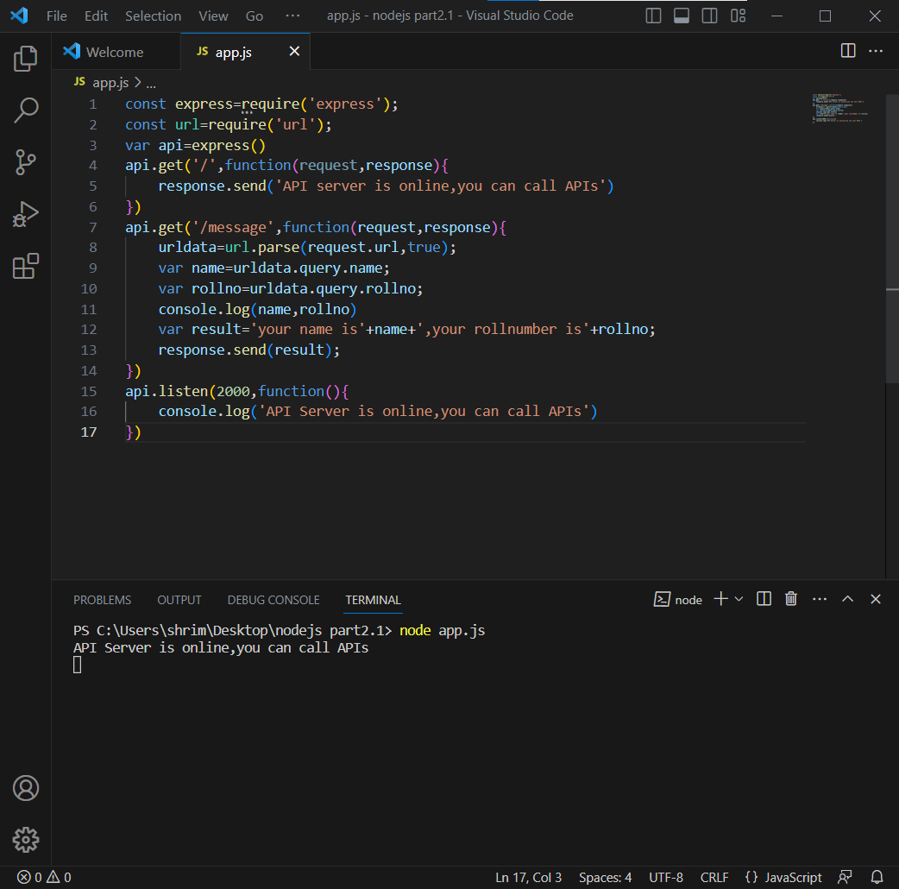copy the url and send the request in postman

You can see that the api server is online and that you can call the apis

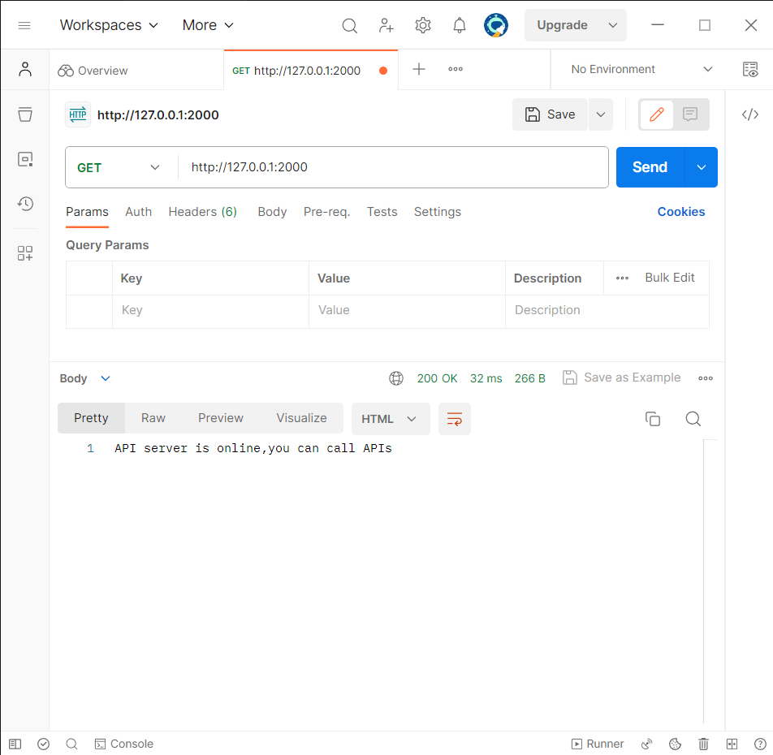

When the key value pairs are appended theoutput is generate as:

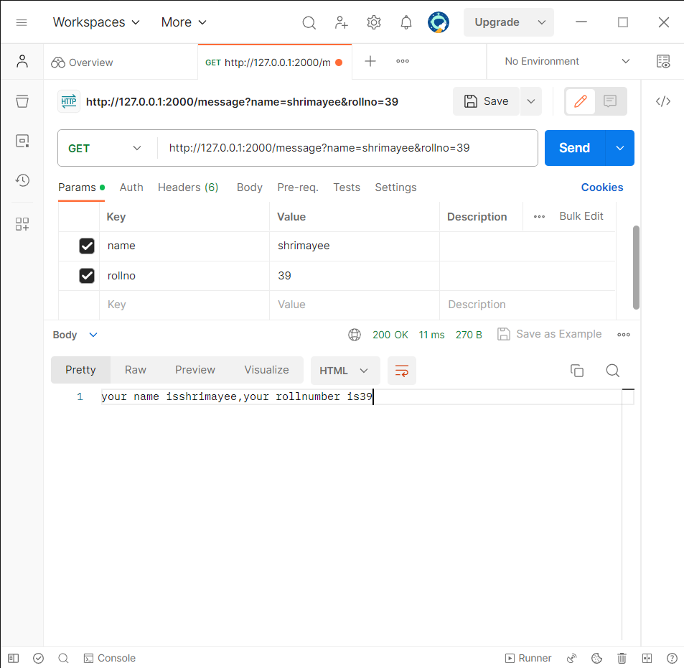

This is the process to code to create an API to collect data from URL using node and express